Test Scenario 1:Check the Login Functionality.

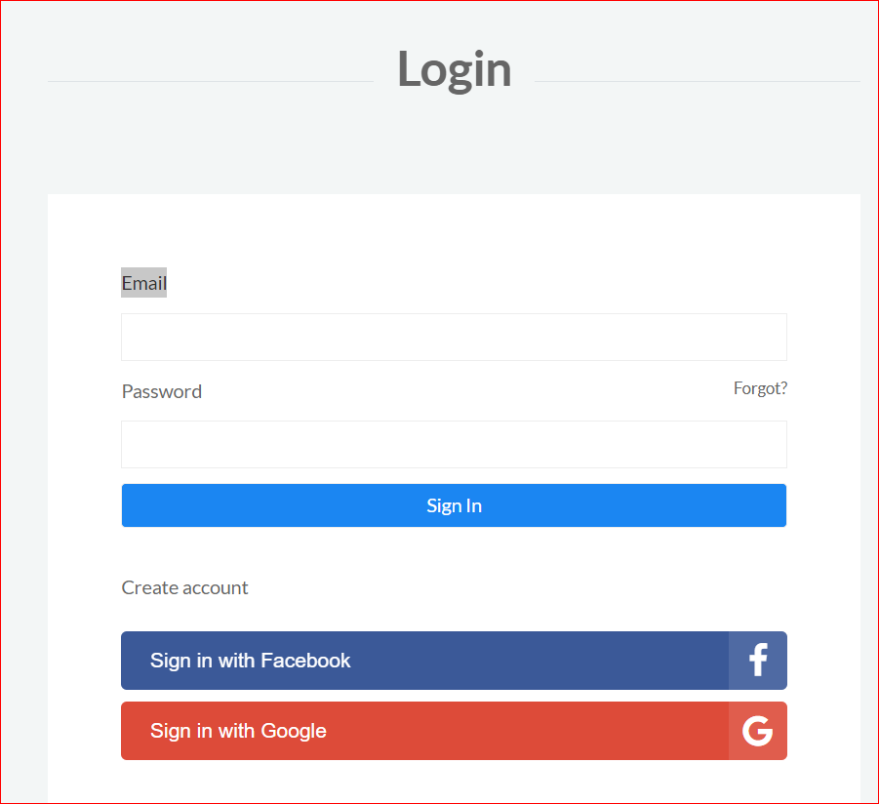

1. Check system behaviour when valid email id and password is entered.
2. Check system behaviour when *invalid* email id and *valid* password is entered.
3. Check system behaviour when *valid* email id and *invalid*password is entered.
4. Check system behaviour when *invalid* email id and *invalid*password is entered.
5. Check system behaviour when email id and password are left blank and Sign in entered.
6. Check Forgot your password is working as expected
7. Check system behaviour when “Keep me signed” is checked

**Test Scenario 2:**Check the Search Functionality

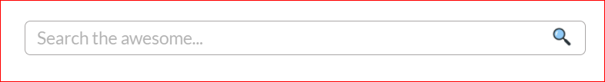

1. Check user is able to type something on the search box
2. Check That User Type something on the search box and product related to that search should be displayed.

**Test Scenario 3:Check Sign-up Functionality is working**

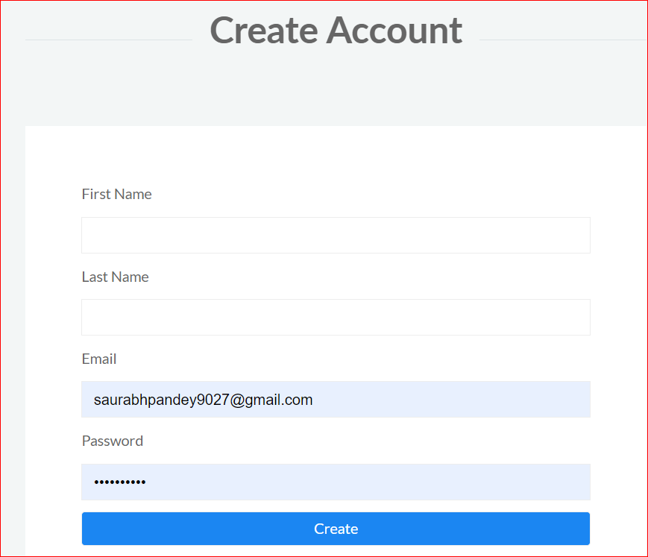

1. Check system behaviour when valid email id , password, First-name, Last-name is entered.
2. Check system behaviour when *invalid* email id and *valid* password First-name, Last-name is entered.
3. Check system behaviour when *valid* email id , *invalid*password, First-name, Last-name is entered.
4. Check system behaviour when *invalid* email id and *invalid*password is entered.
5. Check system behaviour when email id and password are left blank and Sign in entered.
6. Check Forgot your password is working as expected
7. Check system behaviour when “Keep me signed” is checked